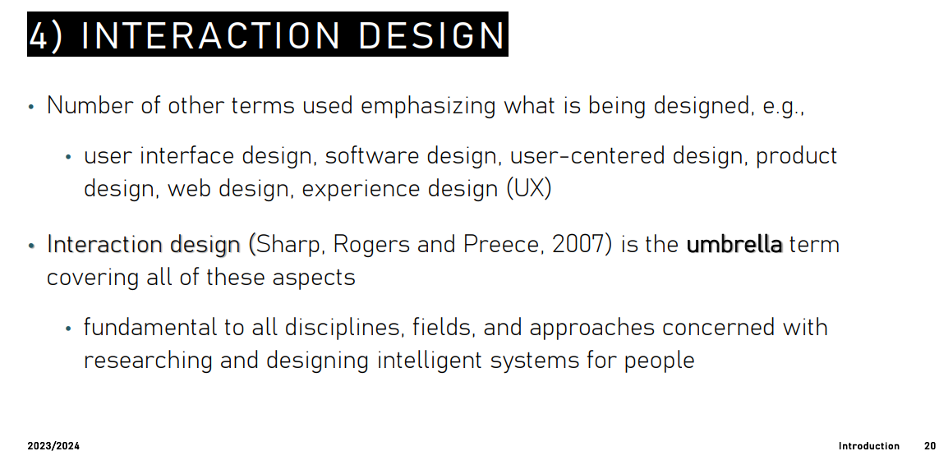
despite some technological advantage in AI field there is been a little research in real word+compl

Cognitive psychology: discipline that explores internal processes such as perception, attention, language, memory, decision making, learning, … it tries to investigate those internal processes. Ask different questions like how people perceive shape or why people remember some facts and when we forget things or how we experience emotions

Cognitive ergonomics (CE): processes of mental processes, such as perception, memory, reasoning but considered in their interaction among humans and other elements of a system. It aims to investigate the relationship between our cognitive system and how it is affected with the interaction of technology.

--23
Human computer interaction (HCI): study how people use and experience interactive technology.

--24
Interaction design: umbrella term that cover user interface design, software design, … fundamental to all disciplines +compl

Cognition
- Experimental vs reflective cognition (Norman)
- Fast (2+2) vs slow thinking (21x29) (Kahneman)

Cognitive processes
- Attention
- Perception
- Memory
- Learning
- Reading, speaking and listening
- Problem-solving, planning, reasoning and decision making

--5
How can understanding cognition help human-AI interaction?
- Offers insight into capabilities and limitation of individual in terms of their expected action
- Explore and elucidates causes and characteristics of challenges individuals confort when utilising intelligent systems
- Provides theories, modelling tools, guidance and methods that can lead to the design of better intelligent products

if we know the characteristic of the user we could avoid him frustration and stress

--6
Perception: psychological process in which we interpret sensory stimulation. Design interfaces that are readily perceivable such as
- Legible text
- Icons easy to distinguish and read

Weller 2004 ⟹ people took less time to locate items for information that was grouped.

Also some argue that too much white space on web pages is detrimental to the search process, makes it hard to find information.

Colour perception
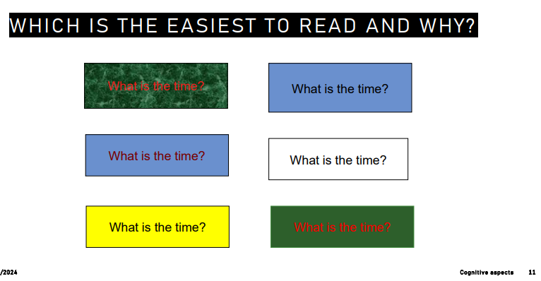
There are three channels: red-green, yellow-blue, black-white.
Use distinctive colour
Avoid colour pairs that colour-blind people cannot distinguish

Separate strong opponent colours, placing opponent colours right next to or on top of each other causes a disturbing shimmering sensation.

The colours that people can distinguish most easily are those that cause a strong signal (positive or negative) on one of the three colour-perception channels.

Gestalt theory of perception
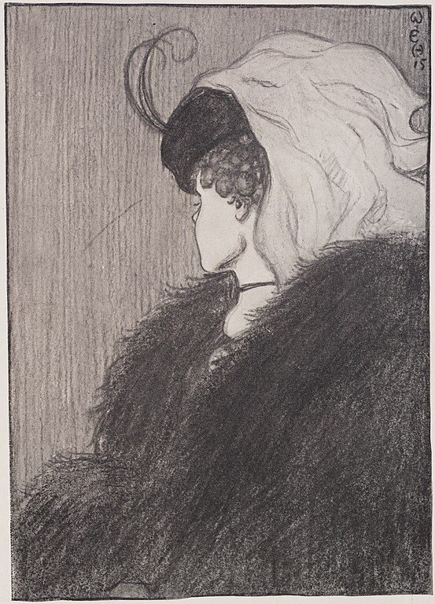
Popular theory, we perceive objects as well organised patterns rather than separate components. Still popular in design.

Proximity
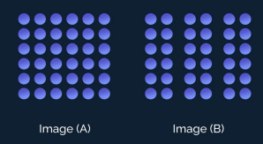
Visual tendency to group together items that are close together. The group will generally be perceived as a single unit

Similarity
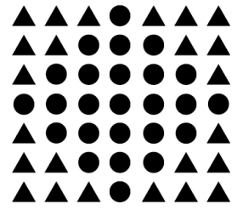
Visual tendency to group together similar elements regardless of their proximity. Can be grouped by colour, shape or size.



Github used to distinguish different sections with different background colours. Different colours ⟹ different purpose. Also links are distinguished from regular text thanks to the colour (blue)

Continuity

Visual tendency to create continuous figures. “Carry the line forward”. Could help the user to navigate the space.

Closure
Tendency to perceive incomplete objects as complete and to close or fill the gaps. We complete according to what we know.

PERCEPTION AND DESIGN IMPLICATION - PART 1
- Icons should enable user to distinguish their meaning
- Bordering and spacing technique to group information
- Research proper colour contrast techniques when designing an interface
- Follow Gestalt’s principles

Perception
Reality ≠ what we see. Our perception of the world around us is not a true depiction of what is actually there

Our expectations are biassed by three factors
- Past: knowledge and experience
- Present: current context
- Future: our goals

--26
We expect and desire consistency. Experience play a role
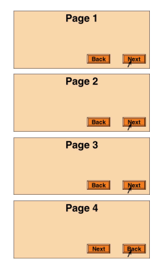

--27

We interpret two letters in different ways depending on the context.

Perception biassed by goals ⟹ our goals influence where we look and our goals sensitise us to what we see

--31
Avoid ambiguity: make sure that all user can interpret the design in the same way
Be consistent: place controls in consistent locations, use consistent shapes, colours, fonts
Understand goals: different users may have different goals, ensure your interface clearly directs users to the right goal.

--32
Attention: ability to respond to stimuli. Refers on how we process specific information present in our environment. Enables us to be selective in terms of the mass of competing stimuli, but limits our ability to keep track of all events.

We can not actively process all the informations that comes from the environment, there is some filters to block some unimportant stimuli

Spacing
Find the prejudice for a double room at the quality inn in pennsylvania

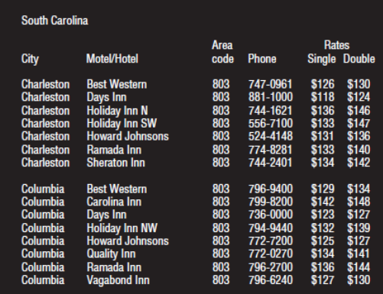
Find the price of a double room at the holiday inn in columbia

--37-
Multitasking: it is possible to do multiple tasks at the same time.

Multitasking can make people make errors, and can have a decremental effect on the performance.

Heavy multitaskers are prone to be distracted than those who infrequently multitask.

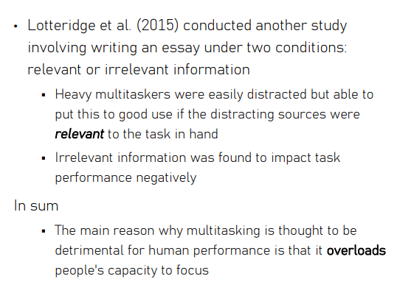

Context: it
It is important to make information that is relevant also for attention.

